Trusted Computing Cluster
Project Outline
Jan Götte <tcc@jaseg.de>
Table of Contents
Scenario 1
Problem Statement 2
On Trustability 3
Solution Outline and Comparison to the State of the Art 4
Use Cases 6
Data Sharing Using Private Set Intersection 6
Auctions and Other Brokerage Models 7
Metadata-resistant (Group) Messaging 8
Medical Data Sharing 9
Intermodal Mobility Brokerage 10

Scenario
Commercial data processing has come to be the underpinning of our economy. We rely on networked computer systems for tasks such as everyday online shopping or B2B transactions. Yet, there are several issues with the data processing landscape as far as safety and security are concerned. First, in many cases, sensitive business data such as purchasing amounts, contact and bank account information and pricing data is routinely processed on commodity server hardware and transferred through ordinary firewalled networks. Most modern computer systems handle either non-public business information or personal private information. Yet, outside of credit card information used for payment processing, the separation between such sensitive data and other parts of the system is often unclear. Security and compartmentalization of data still requires a significant amount of engineering, with highly marketed solutions such as blockchain-based systems often not actually solving the issue in a meaningful way.
Along with this issue of longitudinal separation within one organization’s systems, there also exist an issue of lateral separation where computer systems of different companies meet on the internet. Current approaches to data sharing often involve simply copying over large fractions of a database as EDIFACT or CSV. The terms of the data sharing are contractually agreed upon, but there are little technical measures in place to enforce them. For illustration, consider Facebook’s Cambridge Analytica scandal. Facebook and the company Cambridge Analytica had a contract that clearly stated how Cambridge Analytica is allowed to interface with and use Facebook’s databases. However, there were no effective technical measures in place to enforce this agreement. The result was that over a span of several years, Cambridge Analytica was able to siphon large amounts of individual private information from Facebook. The scheme was only brought to fall when a former employee of Cambridge Analytica blew the whistle.
Besides lack of lateral and longitudinal separation in data processing, the third issue in today’s computing landscape is that oftentimes, the computer systems processing data are themselves only one company’s logical presence within another company’s physical infrastructure. A large fraction of networked computer systems critical to the economy’s functioning is running on the cloud substrate provided by a small number of mostly US-American infrastructure providers. This wide-ranging reliance of the economy on foreign computing and network infrastructure creates a sovereignty issue that we want to explore in the following paragraphs.
In the economical dimension, local companies are subject to foreign economical and political pressure. One recent example of this is the case of Huawei, which clearly illustrated the business impact political sanctions can have on a technologically dependent company.
In the political dimension, the reliance on infrastructure physically located in another jurisdiction and operated by an entity subject to that jurisdiction poses a risk of industrial espionage. A recent example of this is the US NSA’s wide-ranging wiretapping of US-American cloud infrastructure providers that was unveiled with the Snowden revelations.
Lastly, in the social dimension the practical consequences of this reliance can be seen most clearly. It is well-known that US-American societal values are much more conservative in many respects (such as gun ownership, social services and socially acceptable behavior) than what is practiced in most of Europe. An example that illustrates this tension very well is related to US credit card companies’ policies on sexuality. US laws and values expressed in these policies may be seen as prudish by most Europeans, but nonetheless credit card companies enforce these policies through payment processors and down to customer-facing platforms. A visible negative consequence of this is that Patreon, a crowdfunding platform for creative professionals has banned adult content creators from its platform. This by itself economic act is a clear case of cultural imperialism.

Problem Statement
Large parts of the European economy are reliant on a small number of very large US-American cloud infrastructure providers. Simply on-shoring this infrastructure is unlikely to result in great success. Any newly bootstrapped European alternative will be much smaller than the US-American behemoths.
Achieving feature parity with foreign incumbents or competing with them in price is unrealistic as a path to digital sovereignty, as would be a forced change through regulation prohibiting the use of foreign-operated computing resources. A more likely path to success is to acknowledge the historical strengths of European collaboration: Through its functioning democratic process, its strong consumer protection and its progressive stance on human rights as evidenced by the passing of the GDPR the EU has demonstrated that it is willing to put the individual before companies; to embrace social justice over profit. Weaving such considerations into the foundation of a new European cloud infrastructure promises not only to yield a system that is in line with European values, but also promises to create a product that is simply not compatible with the incumbents’ strictly profit-driven business model.
A core component of this alternative model is the federation of resources. While it makes sense to centralize some infrastructure such as networking or computing resources for efficiency reasons, the ultimate control over this infrastructure has to be spread over all participating client companies in a trustable manner. This means that critical parts of the infrastructure that are relied upon for properties such as correctness or privacy of the computation are physically contributed by participating client companies. This removes the reliance on the infrastructure provider for these particular components, while still allowing client companies to profit from the efficiency benefits of centralized infrastructure in all other parts of their systems. The objective is an infrastructure that yields the scaling benefits of centralization while requiring client companies to trust neither the infrastructure provider nor other clients.

On Trustability
Trust is the property of a relationship between a person (the trusting) and another person (the entrusted) or thing that the trusting thinks the entrusted will behave according to their expectations. In the context of modern computer systems, scientists have developed advanced technologies to manage trust. Cryptography can be used to spread trust between entities, or even to make it unnecessary to trust certain parts of a system.
In today’s computing landscape, trusted systems are everywhere. A trusted system is one that the user of a system necessarily has to trust. For example, the keyboard of a computer by itself is a trusted component since the user has to trust it to not modify what is typed, or transmit what is typed to outside listeners.
There is, however, an important distinction to be made between trusted and trustable systems. A trusted component is anything that has to be trusted for the overall system to work. Modern computer systems are full of trusted components. However, not every trusted component is also a trustable component. A trustable component is one that its user can independently verify. Today, in most cases the user’s trust in a complex computer system’s components is based entirely on belief: Usually, the user has no way of confirming the trustworthiness of a trusted component. In any modern computer, the CPU is a trusted component. If the CPU is wiretapped, the user’s data is at risk. Yet, there is no modern computer in which the CPU is a truly trustable component: Be it a server, a laptop or a smartphone, the user has to entirely rely on the CPU manufacturer’s assertions that their chips are “secure”; assertions that the user cannot independently verify.
This trust issue is becoming more acute along with supply chains becoming more complex and systems becoming more interconnected. To remain viable, over the next decades computing infrastructure has to move away from this purely trusted model and towards a trustable model. Components that are de-facto trusted despite being technically untrustable have to be identified, and be gradually exchanged with trustable components that are fit to serve their trusted role.
This dichotomy between practical trustedness and technical trustability has been the basis for works such as Joanna Rutkowska’s past research on x86 platform security that culminated in the QubesOS project as well as the betrusted project by Bunnie Huang et al.

Solution Outline and Comparison to the State of the Art
The technical foundation of our proposed system, the Trusted Computing Cluster (TCC), are the evolved forms of two established technologies: Hardware Security Modules (HSMs) and Secure Multi-Party Computation (SMPC). Secure Multiparty Computation technologies are cryptographic protocols that allow multiple participants to jointly compute some function over private input data without revealing this private data to other participants. SMPC is a powerful concept, and algorithms have been proposed for many practical applications. However, it is not yet widely used in practice since these algorithms are generally considered to be too slow to process practical amounts of data at reasonable cost in hardware and networking.
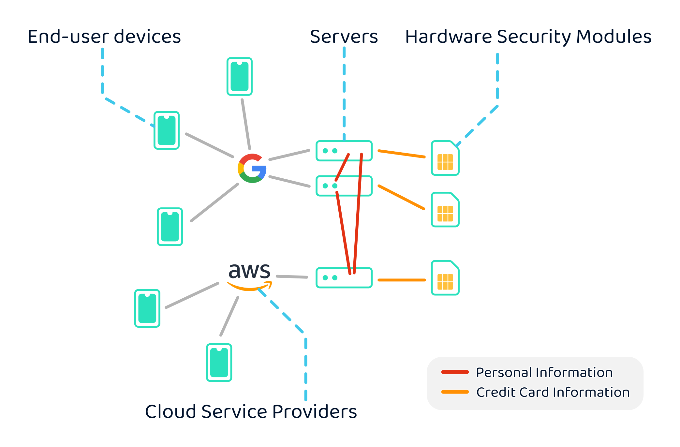Figure 1: Conventional commercial data processing setup
Hardware Security Modules are small cryptographic co-processors that are designed to encapsulate operations that require secret key material into a tamper-responsive physical enclosure. This enclosure is constantly being monitored for physical tampering, and if any is detected within milliseconds all secret data is deleted. Due to their extremely high cost, current HSMs are severely limited in their computational capabilities and are mostly used for simple tasks in electronic payment processing as shown in Figure 1.
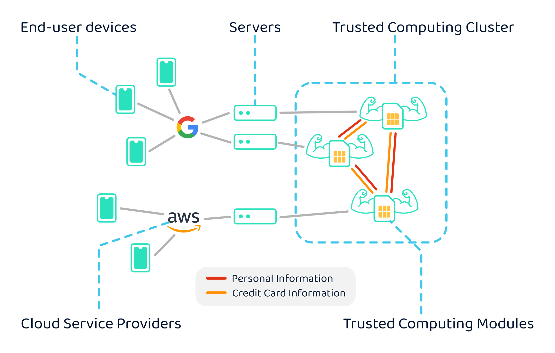
Figure 2: TCC-based commercial data processing setup
The Trusted Computing Cluster combines these two components in a novel way, as visualized in Figure 2: To solve a practical need that can be addressed by SMPC, participating companies co-locate trustable high-power HSMs inside a special co-location space in a local data center. These HSMs, which we call Trusted Computing Modules (TCMs), use commodity server hardware in their core and are designed to be faster than current commercial models by several orders of magnitude. Compared to a traditional HSM, this is equivalent to the step from a smartphone’s quad-core low-power CPU to a modern 64-core high-speed server CPU. The high computing capacity of these HSMs is paired with fast, state-of-the-art network interfaces: While SMPC is usually thought to be limited by the high cost and comparatively low speed of internet transit traffic, these HSMs communicate through meters of fiber-optic cable at speeds upwards of 10Gb/s. This combination of both very high-speed processing and high-speed networking yields a unique setup where SMPC algorithms that have conventionally been considered too slow for practical use are no longer impractical even on real-world volumes of data.
In our model, co-locating data and computation yields very high processing capabilities at low cost. This processing capability unlocks SMPC algorithms that allow participating companies to gain useful insights on their data, while the HSMs’ security boundaries protect their secret data in a trustable way that measures up to the sensitive nature of the data within.

Use Cases

Data Sharing Using Private Set Intersection
The Platform Economy has brought e-commerce to the masses. One of several reasons for its success is its convenience: A user wishing to buy something on Amazon types the search term in their browser’s address bar, selects Amazon as their search provider, clicks on the desired product, clicks on “Buy now” and the item gets shipped to them. Amazon already knows their name, address and bank information and can start processing the order immediately. The entire process can be completed in just three clicks or taps. The owner of the business providing the actual item to Amazon is at no point apparent to the customer.
Compared to this, the ordering process on more traditional, non-platformed online shops is more cumbersome to the user. After finding the product listing on the online shop and adding it to their virtual shopping cart, they will have to go through a data entry process that requires them to enter all 10 or so fields of personal data required for order processing. For fraud prevention purposes they may even be forced by the shop’s payment providers to give up their mobile phone number or go through a complex, multiple-step confirmation process to confirm their payment. This presents a severe usability issue that puts small and mid-sized businesses that wish to do their own order processing at a disadvantage vis-à-vis the platform incumbents.
To bridge this usability gap, multiple small and medium-size companies could band together to mutually share customer data required for order processing. The obvious approach to this would be to create a new platform specifically for data sharing, alas this approach is subject to issues both with respect to customer privacy and fraught with potential for abuse. In addition, the advantage of signing up for this other new platform would be hard to communicate to potential users, limiting its short-term adoption. GiroPay and now PayDirekt are examples of a European federated payment processing platform that attempts to compete with the large credit card companies and whose history exemplifies this adoption issue.
A better solution in this scenario would be to employ private set intersection algorithms running at large scale on a Trusted Computing Cluster to share this data. In a basic scenario of shop owners, customers and the infrastructure provider every shop owner has a Trusted Computing Module deployed at the infrastructure provider’s co-location facility. Each shop owner stores a copy of their customer data well-protected within the confines of their own TCM. When a customer wishes to check-out at one of the shops, in addition to the usual “Register as new customer” and “Checkout as a guest” options the shop offers a “Buy using TCC” option. This option presents the user with an entry field to enter an identifying datum of their choice such as mobile phone number, email address or name and birth date. This identifying data is then sent from the shop front end to the shop’s TCM, which will initiate a private set intersection (PSI) protocol run with the other co-located TCMs. Due to the high bandwidth offered in the co-located setup this PSI protocol run will quickly conclude and give the shop front end an indication if the user is already registered with one of the partner shops, without leaking any other information such as which particular partner the user is registered with. The front end can then tell the TCM to initiate a private 1-1 messaging protocol with the matched data holder. The data holder can then ask the user for permission to share their data out-of-band, e.g. through the customer’s contact email address on file. The customer can confirm the request with a click on a button in the confirmation email and the data holder can then proceed to provide the requesting shop TCM with the customer’s data.
Superficially, this system may seem similar to the workflow enabled by OAuth as well as a variety of “Sign in with company” services. Systems like OAuth solve authentication (“Who is this user?”), but do not provide primitives for data handling (“Where should I ship this order?”). The platform sign in services can solve the latter, but in their case all data goes through the platform; the platform’s sees where and when the user is shopping. In the TCC scenario outlined above, there is no platform. The only information that is shared between parties is the minimum amount necessary: “Is this user registered with anyone?” is determined through PSI without the user or the data holder’s identity being leaked to anyone. “Where should I ship this order?” is answered without either of the two shops, the original data holder and the new data holder learning each other’s identity.

Auctions and Other Brokerage Models
A business use case where privacy can be of the utmost importance are auctions. In several auction models, the identity of bidders is kept secret during the auction as a means to increase fairness and ultimately efficiency. Various auction types can easily be mapped to SMPC primitives such as private broadcast in case of the English auction as one knows it. In a Private Broadcast-based setup clients would have to trust neither the infrastructure provider nor would they need to trust a bidding proxy to hide their identity from other participants. On a TCC setup, even with large numbers of participants, Private Broadcast algorithms can be run with low latency.

Metadata-resistant (Group) Messaging
The Signal private messenger is a prime example of the commodification of end-to-end encrypted (E2EE) text messaging. Users of Signal have cryptographic certainty that the contents of their communication can never be read anywhere but the intended recipient’s device. Despite this very high level of security there is a key secrecy criterion Signal and other private messengers currently completely ignore for practical reasons: Metadata resistance, or the ability to keep not only the contents of the communication but also the fact that certain users communicated hidden from anyone, even from a well-funded global passive adversary. The global passive adversary is a model that matches most large foreign secret services that can be assumed to have a network presence where either the messenger service’s servers are located or where its users are. To put it simply, Signal can prevent the NSA from outright reading the text messages that e.g. I exchange with my mom. It cannot prevent the NSA from learning that and when I messaged my mom. In this particular instance one can attempt a nothing-to-hide argument. This argument does not hold in the general case. There are everyday situations where this metadata can be as strategically important as the actual contents of the communication.
Throughout the years a multitude of attempts have been made to approach this issue. Around the turn of the millennium the field of cryptographic messaging protocols flourished with various models being explored, from ones that require only a single honest party to ones that require a fraction of participants to be honest, and from ones that off-load most of the computation or network communication to a pre-processing phase to ones that do all processing and communication in-line with the main protocol execution. After its initial boom the state of the art in these protocols has gradually advanced throughout the last two decades. Today, we look at a well-researched landscape with many options for trade-offs between parameters such as communication and computation costs. Alas, there remains a common flaw even in the most recent approaches: None are practically usable in today’s private messaging landscape. Their most common ailment is that to achieve security, the protocol has to compromise on both communication cost and on computation cost. The design space has been explored exhaustively and yet still no protocol has been found that can practically scale to billions of users in total and billions of messages per day. A particular pain point is the information theoretic requirement that when nothing is sent or received, cover traffic has to be sent to prevent a listener from recognizing communication from associated blips in traffic patterns.
The main reason the efficiency issues of these protocols cut as deeply as they do is that to be useful these messaging applications require the protocol endpoint to be the user’s smartphone or laptop. On both computation is limited by the amount of battery life that the user can tolerate losing, and though with 5G and the proliferation of WiFi even in less advanced countries such as Germany users’ instantaneous bandwidth is good, users still cannot afford to transfer hundreds of megabytes of data per day to have their private messenger do its thing in the background.
Reasoning on a more basic level we will discover that this is a limitation on the use of private communication protocols and not one on the use of private communication per se. Consider how we interact with text messengers—ignoring comfort features such as stickers and pictures for now. The interface between messenger and user in the end is written text. The rate at which a human can read text is limited to less than 1,000 words per minute, corresponding to about 1kb/s of information. Thus, on a very basic level for metadata resistance alone 1kb/s of cover traffic at the end device should suffice. 1kb/s corresponds to about 350MB per month of data, which is both very technically feasible and easily within the means of many people’s mobile data contracts.
After solving metadata resistance like this we are still left with the other issues of private communication protocols. 1kb/s may be enough to saturate the human mind’s reading comprehension capabilities, but it is most certainly not enough to run any reasonable instantiation of a cryptographic private (group) communication protocol.
TCCs are the place where this practical issue can be solved. If the user is content with metadata resistance and E2EE being solved at their end device, they can delegate running most of the private communication protocol to a TCM inside the TCC. They have to trust the TCM to some extent, since a malicious TCM can still do some of the traffic metadata analysis the protocol is designed to prevent. In turn, the TCM performs most of the private communication protocol on its own. Since the TCMs are powerful machines connected through unmetered, high-speed networks they can simply absorb a large part of the inefficiency of private communication protocols allowing these protocols to scale to load scenarios even their authors likely did not expect to be practical.
The resulting system is one that compared to the state of the art provides significantly improved metadata resistance while making no compromises with respect to scalability. Applications for such metadata-resistant (group) communication are e.g. business negotiations between companies, political negotiations and even communication relating to business secrets within companies. In each of these applications the communication metadata alone can carry significant intelligence value, and the likelihood of it being exploited gets exacerbated if the messaging system’s back end is situated in another country or if its users are spread out throughout several jurisdictions.

Medical Data Sharing
In our society, medical data is the most sensitive category of private personal information. At the same time, it is the basis for much of modern science and innovation in the medical sector. Although we have entered an age of unprecedented creation and accumulation of such data, current research is held back to some extent by the logistics of handling this data that in practice amounts to a kind of hazardous material. While usually applied to nations, the term digital sovereignty here means that the patient alone should be in control of their data. They alone must decide what is stored and they alone must decide how it is used. Throughout the coming-of-age of global-scale interconnected computer systems there have been various ideas for technological solutions for this tension.
A noteworthy strain of these ideas are ones that confuse blockchain for a privacy technology. As an example, take the medical data sharing use case of the GAIA-X project. Here, blockchain is used as if it would mean secure multiparty computation and it is postulated that a single technology provider (GAIA-X) can be relied upon as a centralized provider for the trusted components needed in such a setup. Applying this use case to the Trusted Computing Cluster outlined above, we can see that this approach will yield much more practical trustworthiness compared to a setup based on commodity hardware in the data centers of a cloud service provider that differs from the likes of Amazon and Google only in its political conception.
In this example, one would replace the incorrect use of blockchain technology with the appropriate SMPC constructions. With such algorithms running on TCC hardware, there no longer is a single point of failure in the cloud infrastructure provider, and despite the hardware being co-located in a shared space there is no risk of physical compromise either. At the same time, TCC co-location provides the SMPC software with ample bandwidth to churn through large numbers of records quickly.

Intermodal Mobility Brokerage
The last few years saw a significant evolution in the European mobility landscape. From the rise of private long-distance bus lines to the continuing diffusion of small vehicle sharing systems in major cities, today’s transportation landscapes offers a wider selection to consumers than it ever did. Albeit it yields unprecedented consumer choice, this patchwork of services also presents the consumer with a planning problem. Apart from few exceptions cross-provider integration is still poor.
There exist some companies that attempt to situate their products as mobility marketplace platforms (e.g. Jelbi and Google Maps), but vehicle sharing companies often have their own visions of their own apps as such mobility brokerage platforms and are reluctant to enter third-party platforms. One way to break this tie might be to create a truly vendor-neutral platform based in a TCC. The TCC can be used on the business end of the contract to prevent a participating company’s competitors from learning insights about their business. Being algorithmically neutral by design, competing companies can rely on the platform providing a level playing field to them. On an individual level, a TCC can share trust between several independent participating companies. Beyond the practical privacy that more centralized platforms may or may not provide, a TCC-based system is trustworthy so the customer can actually rely on these privacy claims.

Sources of Third-party Material
Figure 2: “Muscle” icon by “Those Icons”

https://www.qubes-os.org/
https://betrusted.io/
https://www.data-infrastructure.eu/GAIAX/Redaktion/EN/Artikel/UseCases/patient-empowered-privacy-secured.html

